**Probabilistic Selection Task**

Turn on laptop computer (“on” button on upper right immediately above keyboard). Insure charger and portable mouse are plugged in. Login with your FIU credentials. Once you and participant are in front of the laptop, **open finder window and open Local Disk (C:)/eprime/PST.ebs (the purple icon).**

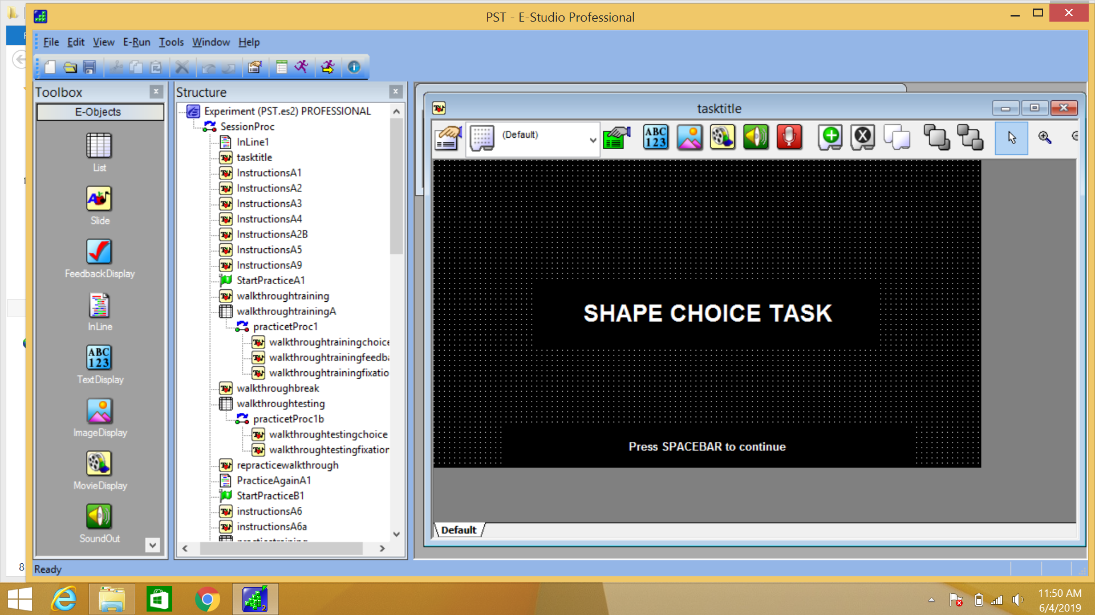

**1.** [Enter participant number and leave session number as default “1”]. Now I am going to teach you the Shape Choice Task. You will only do this task once here in the behavioral room. You will not do this task in the scanner. [press space].

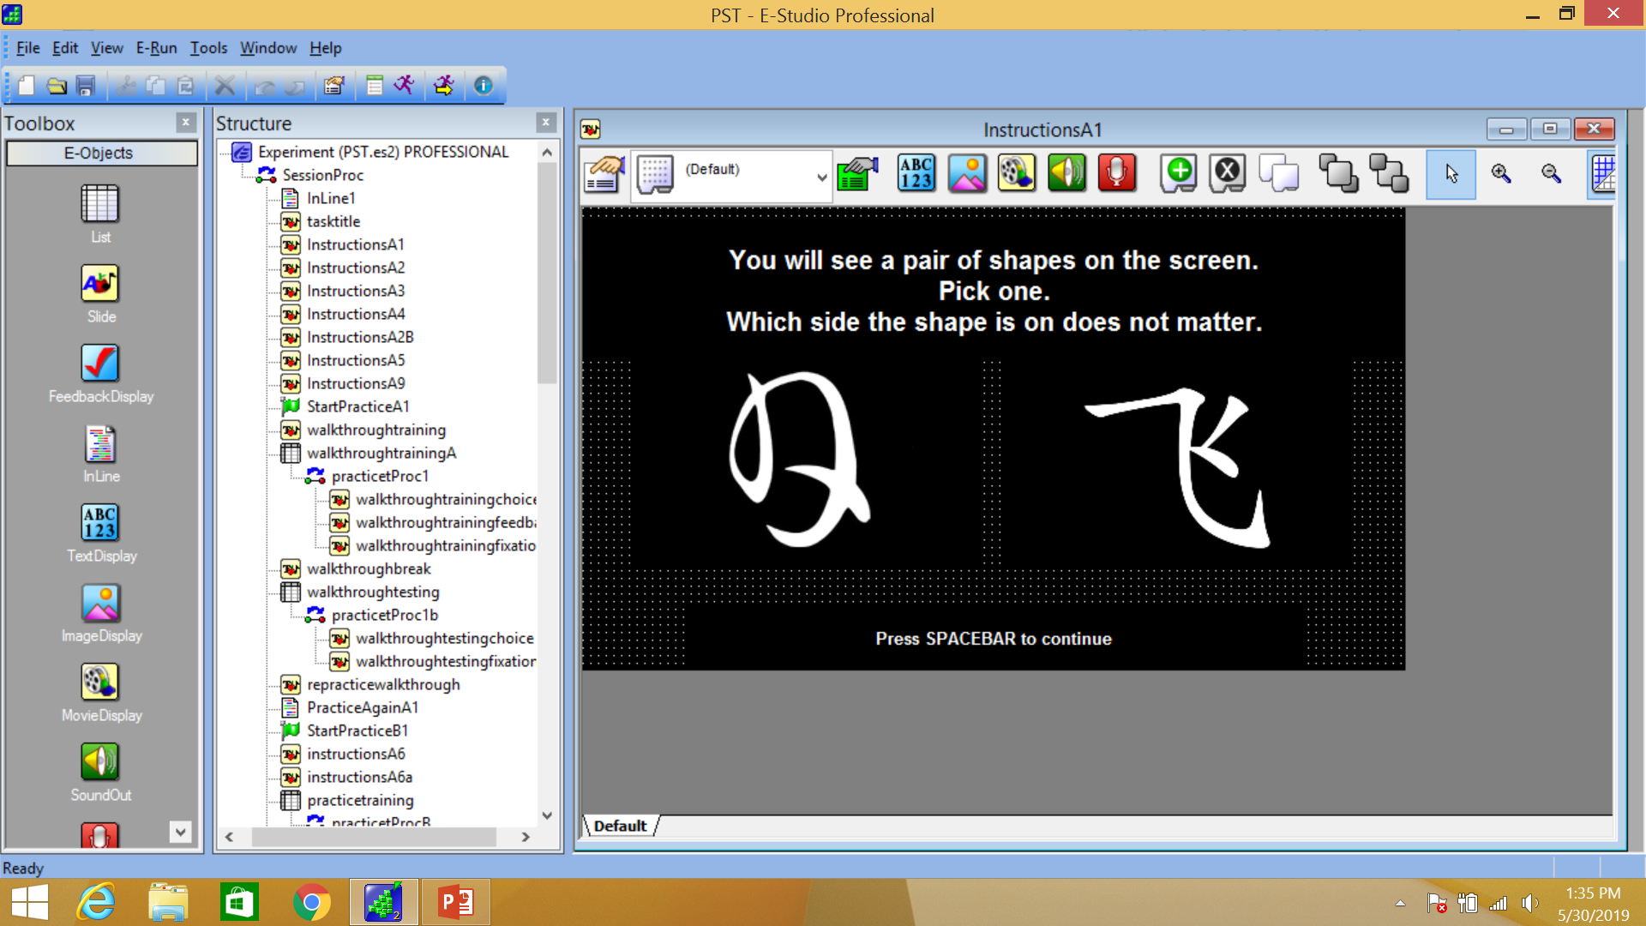

**2.** In this task, you will see pairs of shapes pop up on the screen. One of the shapes will be the “correct” one and the other shape will be the “wrong” one. Your task is to figure out through ‘trial and error’ which shape is the “correct” one. To get started, you just need to randomly choose one of the shapes. You will make your choice by pressing a button, that I will show you next.

When playing this game, you will see several pairs of shapes. One thing to keep in mind is that the side of the screen the shape is on does NOT matter. The shapes will switch places from the left side and the right side sometimes. It is the shape that is important and not the side of the screen [press space].

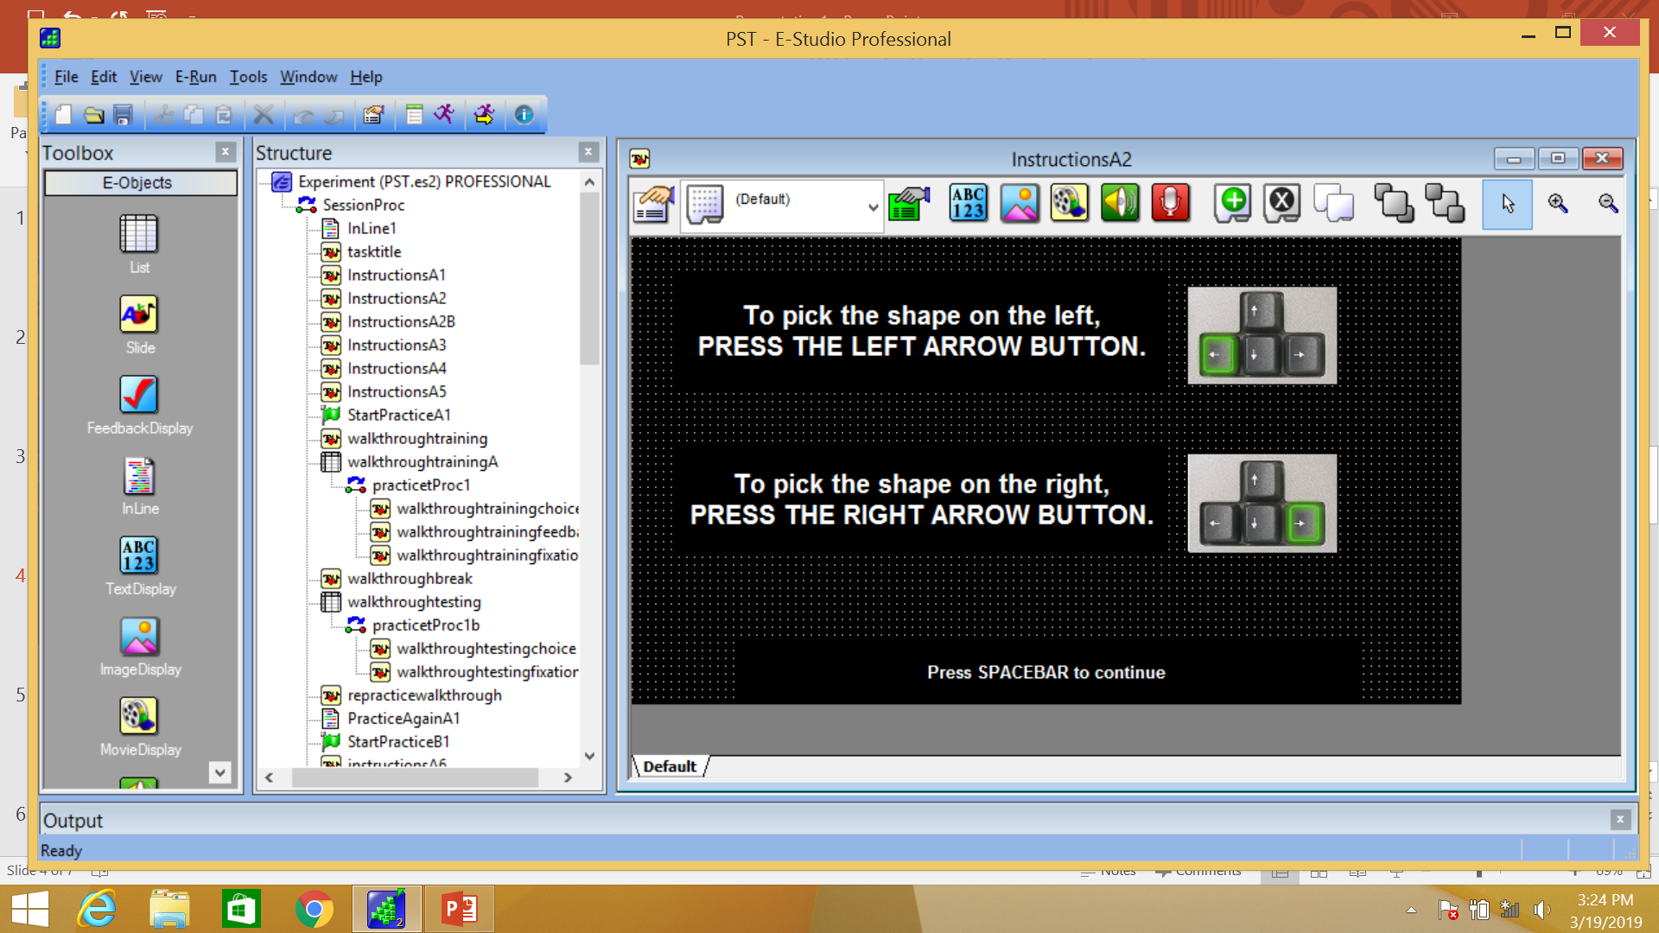

**3.** You will use these two arrow buttons to choose a shape. You should position your pointer and middle fingers on the arrow-keys like this [show them]. To pick the shape on the left you will press this left arrow button (index finger). To pick the shape on the right you will press this right arrow button (middle finger). [press space].

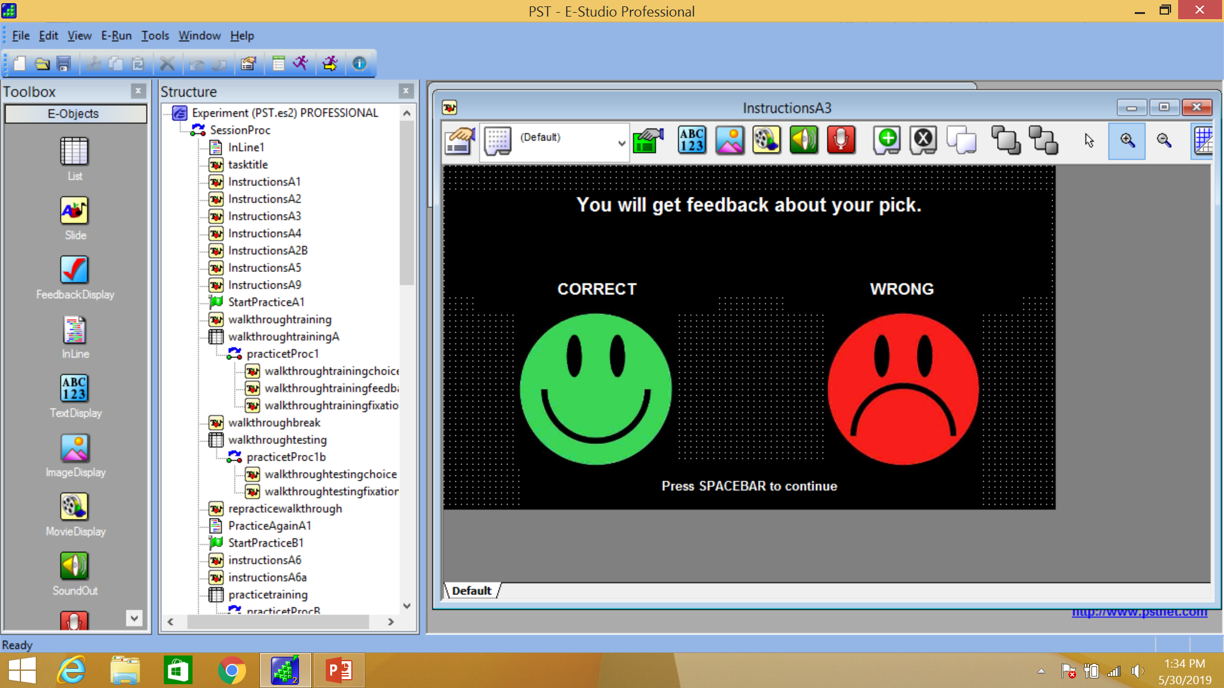

**4.** To figure out which shape is the “correct” one, the computer will give you feedback about your choice. If you picked the “correct” shape, the computer will show you the green happy face. If you picked the wrong shape, the computer will show you the red sad face. Use this feedback to figure out which is the “correct” shape. [press space].

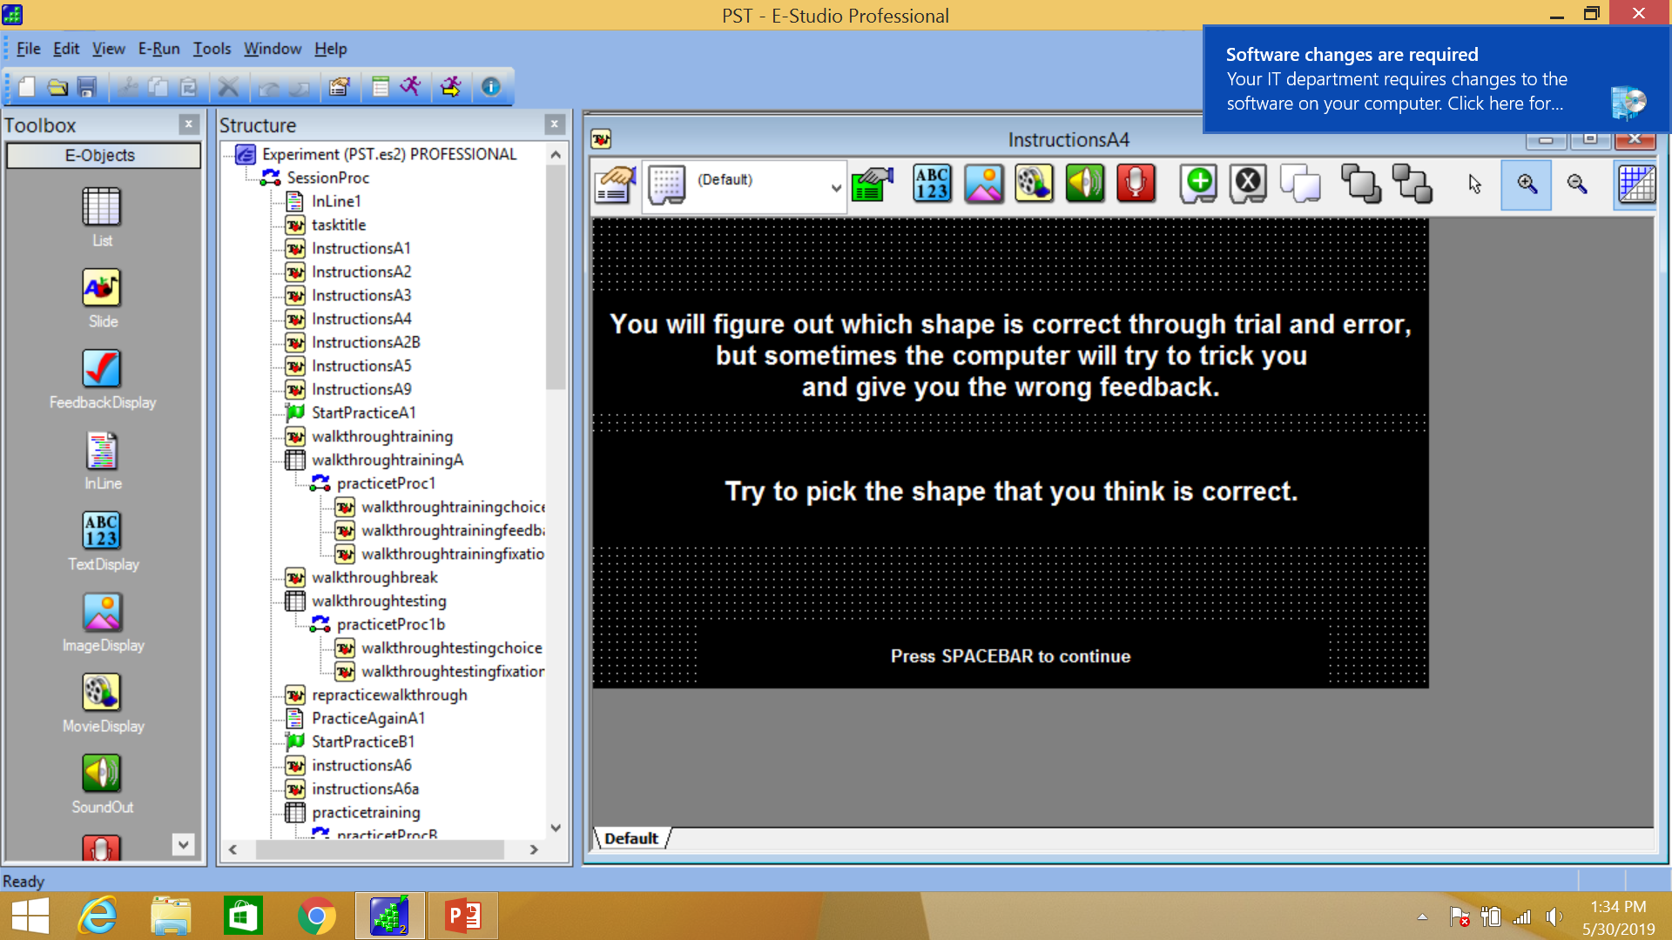

**5.** At first, you will not know which shape is the “correct” one. You will need to figure that out through “trial and error” using the computer feedback. That sounds easy right? That would be too easy for you, so we need to make things a little harder. Sometimes the computer will try to “trick” you and will tell you your pick was wrong even when you chose the “correct” shape. In other words, sometimes the computer will “lie” to you to hide which shape is the “correct” one. Just keep trying to pick the shape you think is correct [press space].

Does that make sense? If not, try to re-explain. We will practice together to make things more clear.

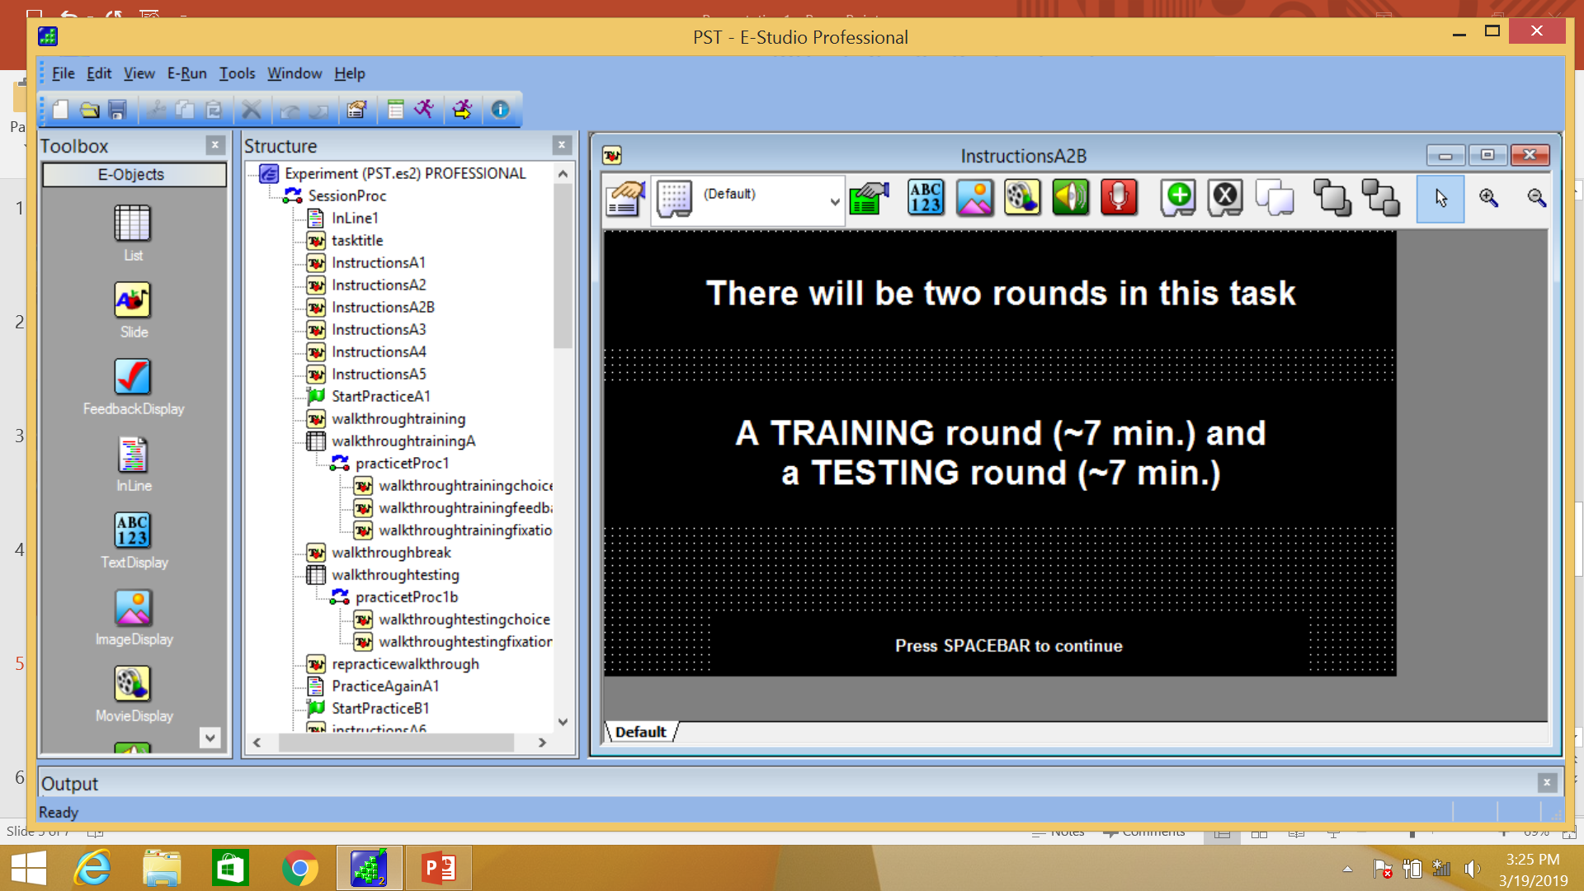

**6.** There will be two rounds in this task. The first round we call the training round. The training round will take about 7 minutes. The second round we call the testing round. The testing round will also take about 7 minutes. [press space].

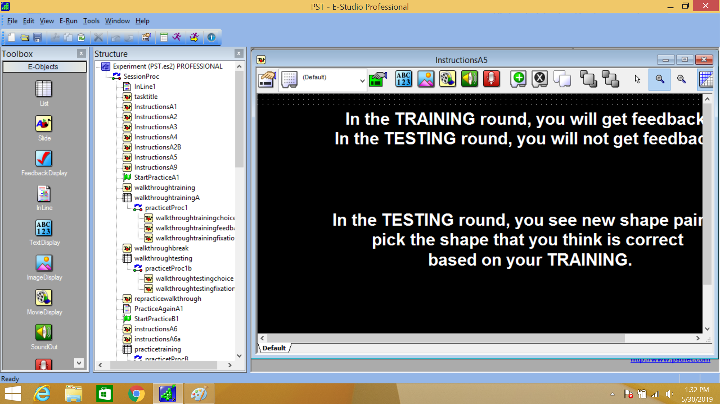

**7.** In the training round you will get feedback to help you figure out which is the correct shape. But, in the testing round, you will NOT get feedback. In the testing round, you need to rely on what you learned during the training phase and pick the shape that you think is the correct shape.

In the testing round, you will see shape pairs that will be different from the ones you saw during the training round. Simply choose the shape you think is “correct” or the “best choice” based on your training. If you are not sure, give your best guess [press space].

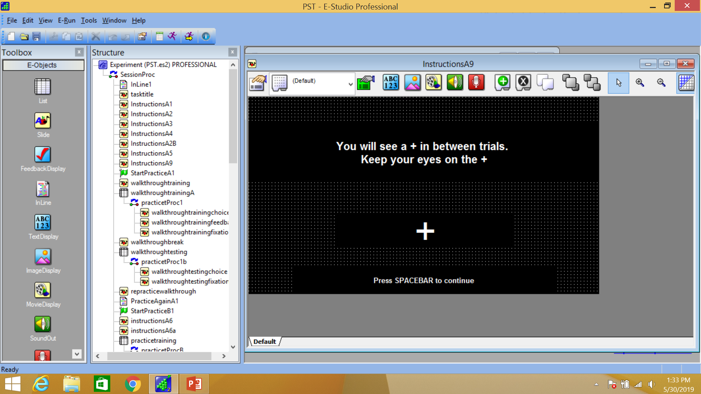

**8.** In between the shape pairs, you will see a plus sign or cross. The cross is to help you stay focused on the screen. You should keep your eyes on the cross. [press space].

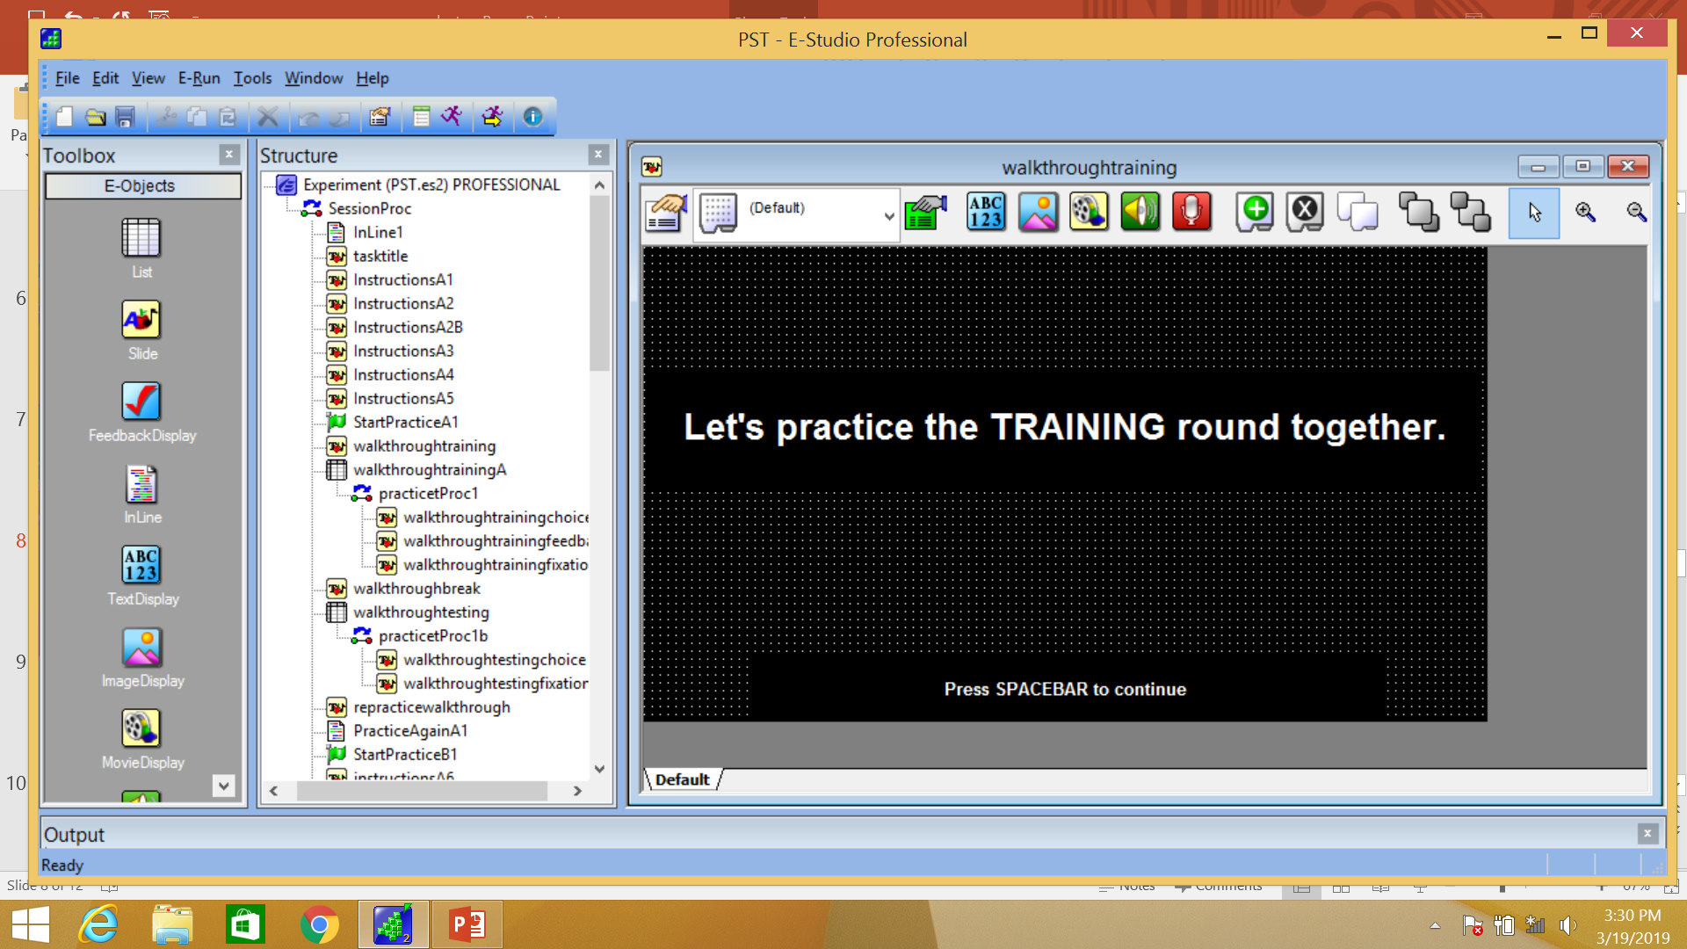

**9.** Let’s practice the training round together. [press space].

**Training Walkthrough: three trials with practice shapes.**

**(1: shapes, 2: feedback, 3: fixation cross).**

**10.** [press the arrow keys to move through screens]. In the **training round** you will see a pair of shapes like this. Let’s say I wanted to pick the shape on the right. [point to shape on right]. I would press this right arrow button. [press right arrow button]. Looks like I was correct. [REPEAT for other trials.]

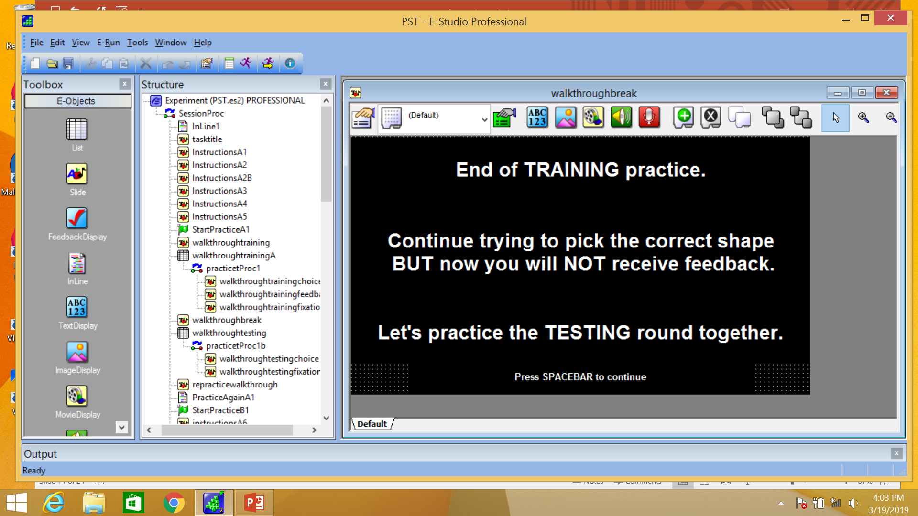

**11.** When the training round of the task is over you will see a screen that looks like this and says “End of training”. You should continue trying to pick the “correct” shape based on your training. But, remember, during the testing round you will not get feedback.” Let’s practice the **testing round** together. [press space].

**Testing Walkthrough: three trials with practice shapes.**

**(1: shapes, 2: fixation cross).**

**12.** [press the arrow keys to move through screens]. In the testing round, you will see new shape pairs. Pick the shape you think is “correct” or the “best” choice. [press arrow]. But, again you will not get feedback. [press arrow]. You will just move on to the next pair of shapes. [press arrow]. Again, pick the shape you think is correct based on what you learned during the training [move through all trials.]

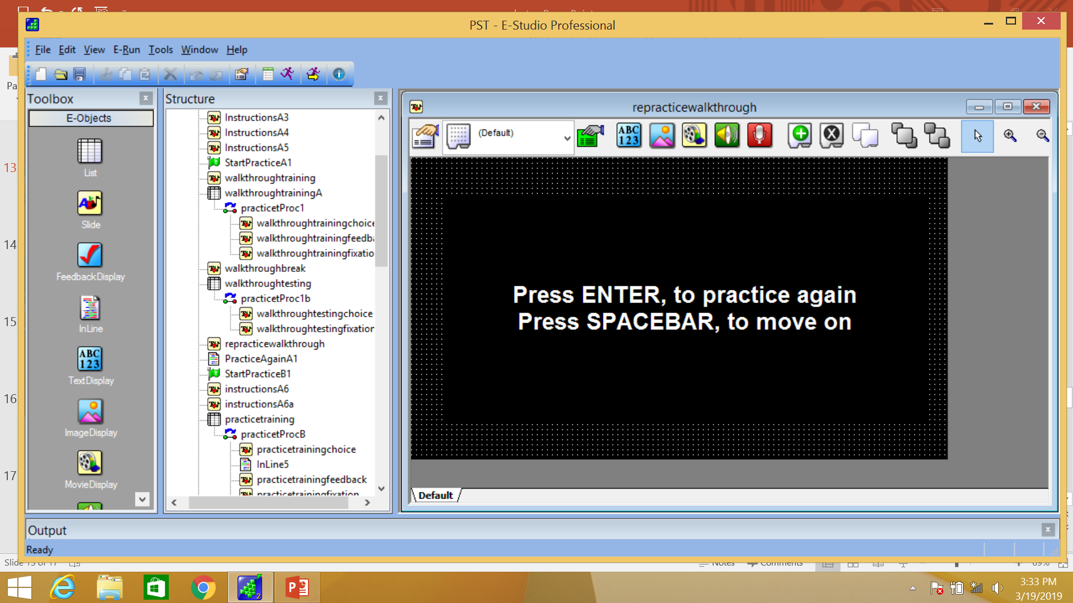

**13.** Do you feel like you need to go through the instructions again, or would you like to move forward and practice on your own? [press **enter** to re-practice and press **space** to move on].

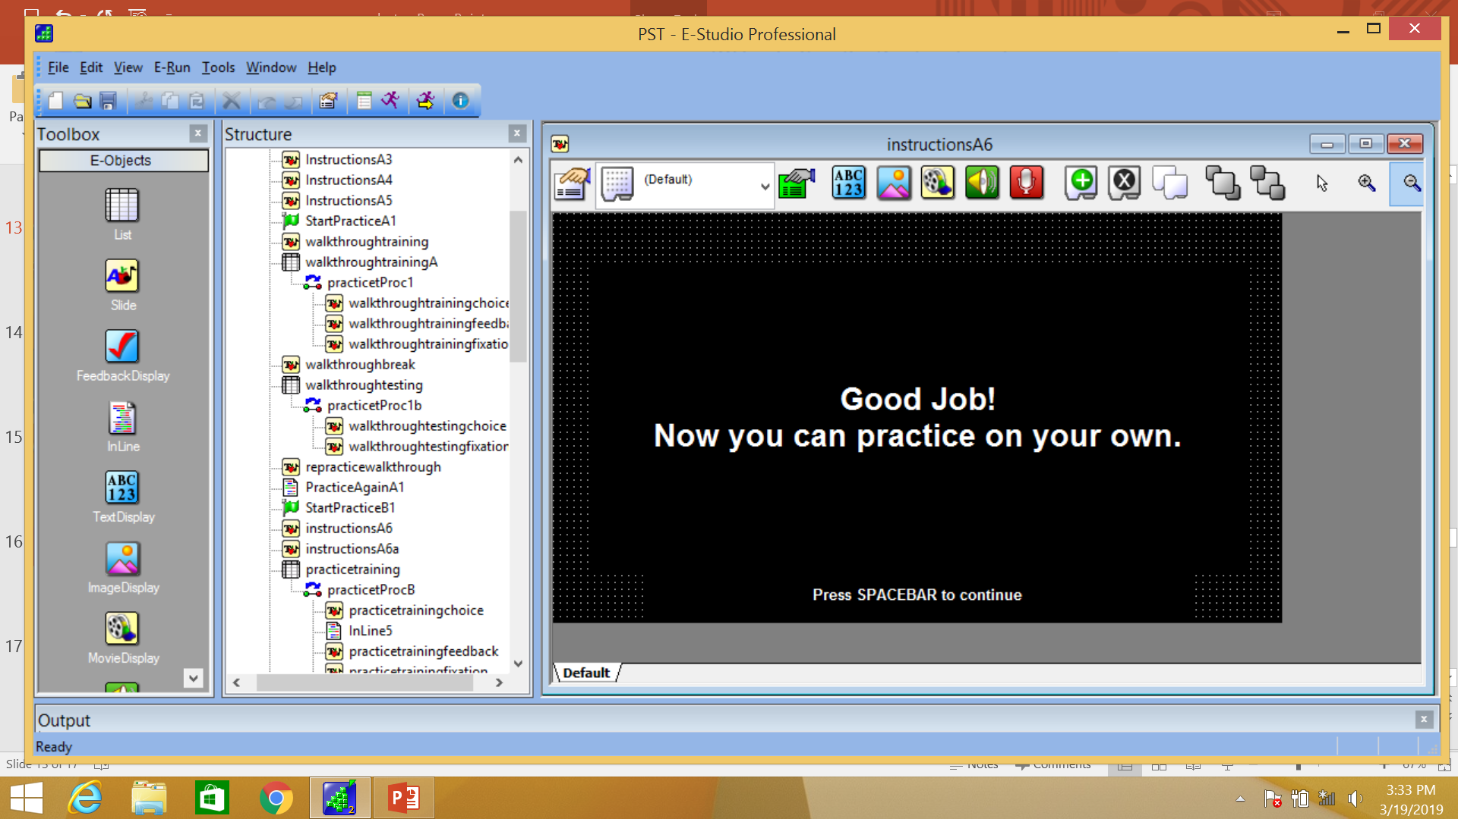

**14.** Great job! Now you can go through the training and testing practice rounds on your own. These practice rounds will have practice shapes. There will be new shapes once you start the real task. So, you can put your fingers on the arrow keys to get ready. Press **spacebar** when you are ready to begin. [participant presses space].

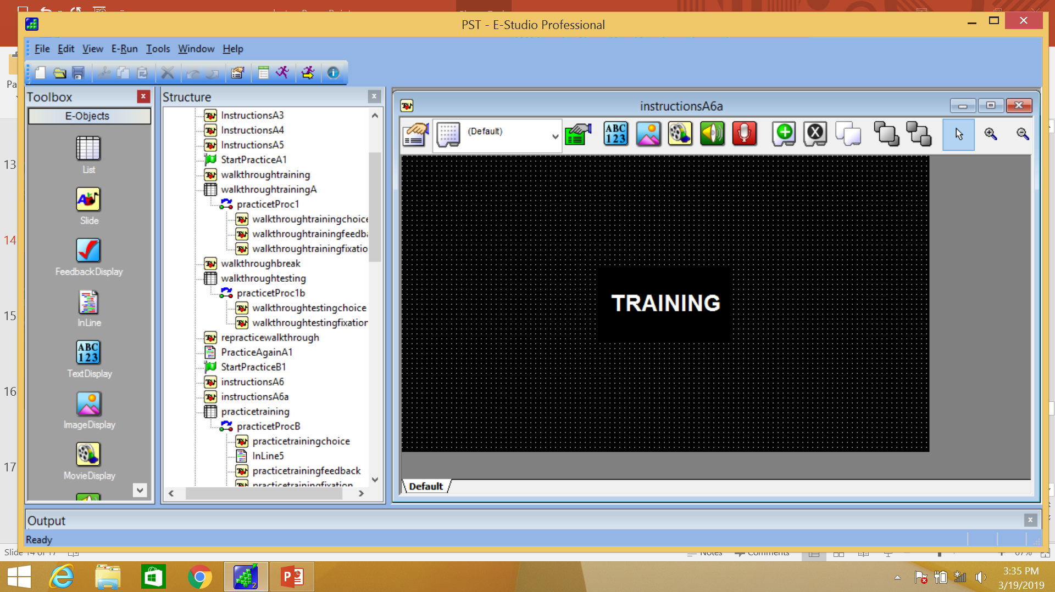

**15.** Move computer in front of participant and sit quietly. Answer any questions they have but try to keep them from talking and getting distracted from task. Watch the participant and responses to ensure that they are doing the task appropriately.]

**Training Practice: 30 trials with practice shapes.**

**(1: shapes, 2: feedback, 3: fixation cross).**

**16. Participant completes 30 trials of training.**

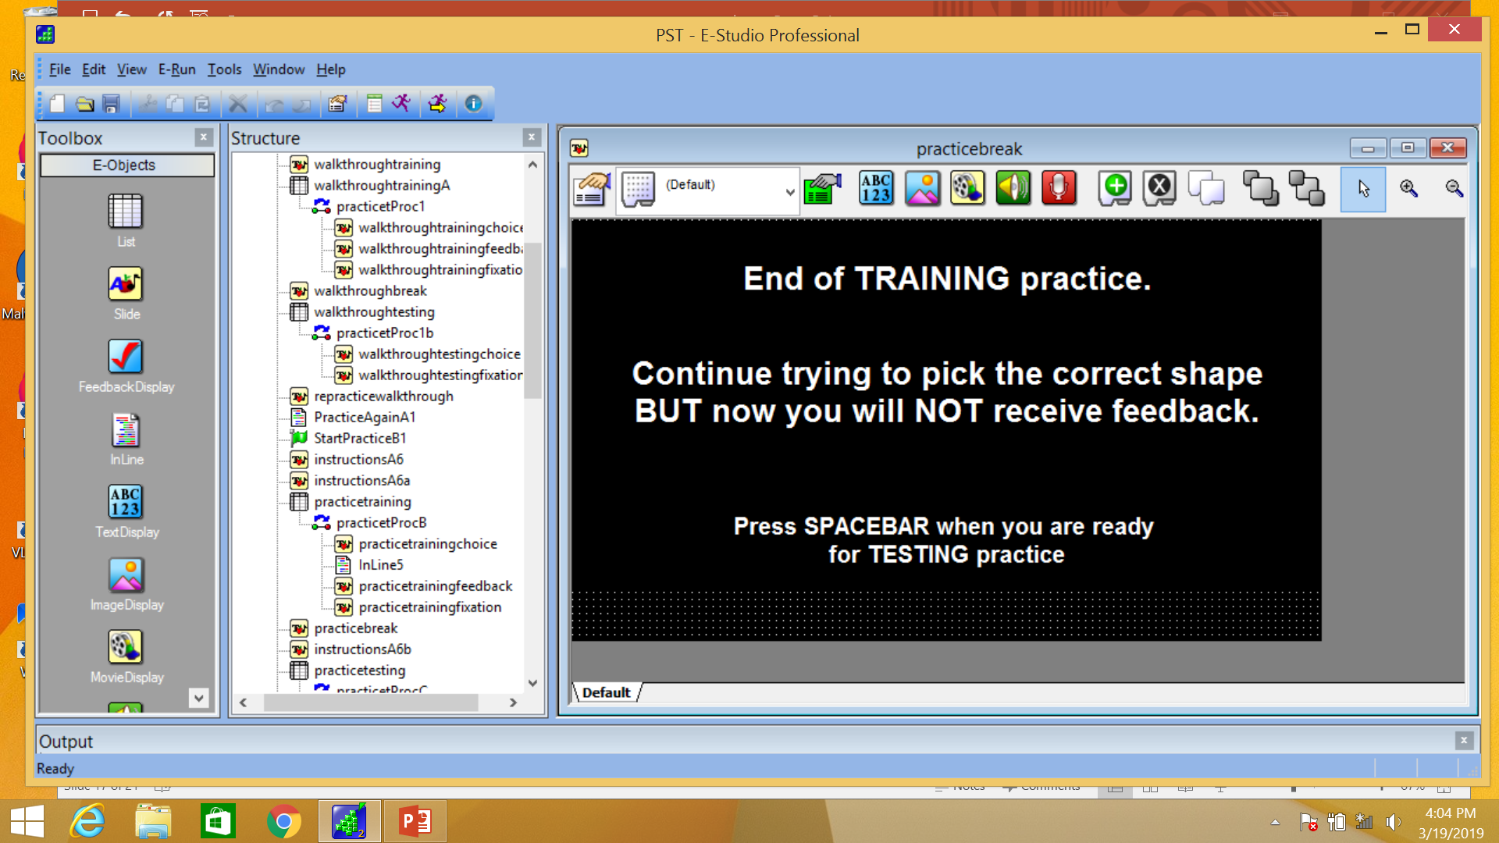

**17.** Again, when the training round is over, you will see a screen that looks like this and says “End of task training”. You should continue trying to pick the correct shape based on your training. But, now you will not get feedback.” Press the **spacebar** when you are ready for the testing round [press space]

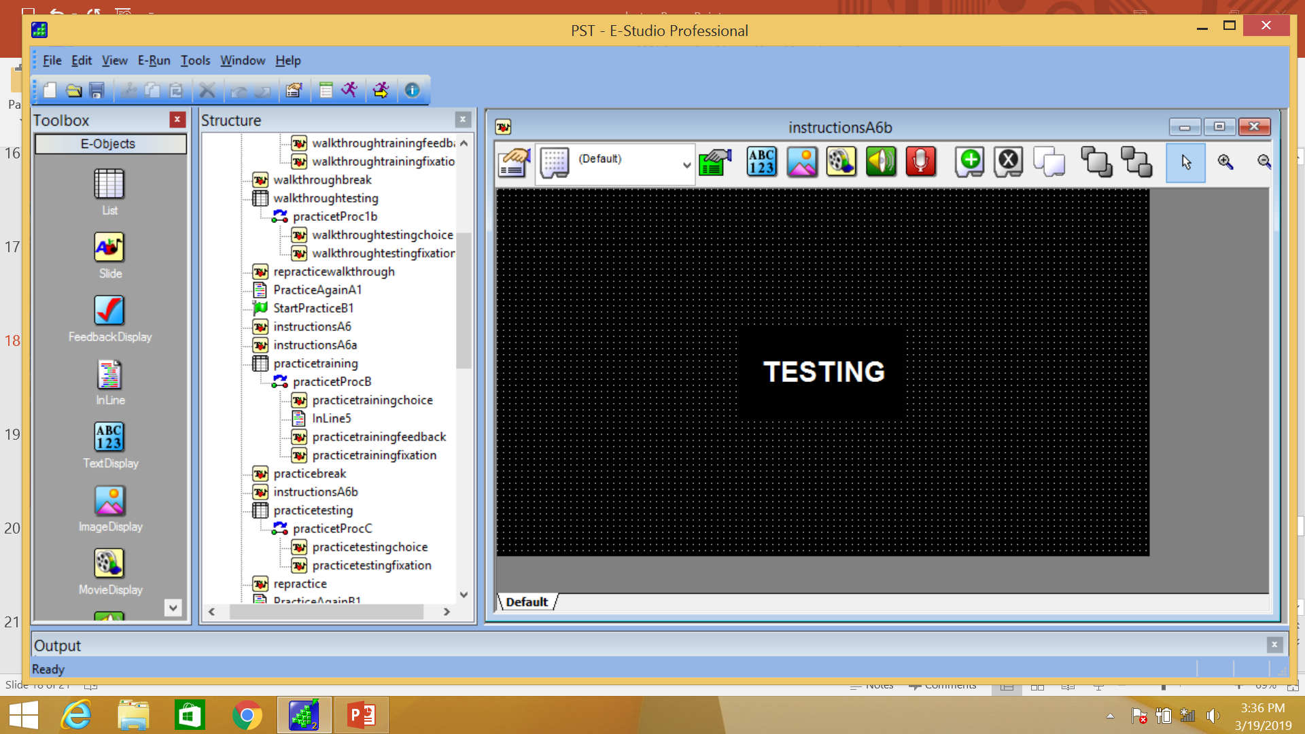

**18.** [Computer in front of participant and sit quietly. Answer any questions they have but try to keep them from talking and getting distracted from task].

**Testing Practice: 10 trials with practice shapes.**

**(1: shapes, 2: fixation cross).**

**19. Participant completes 30 trials of testing practice.**

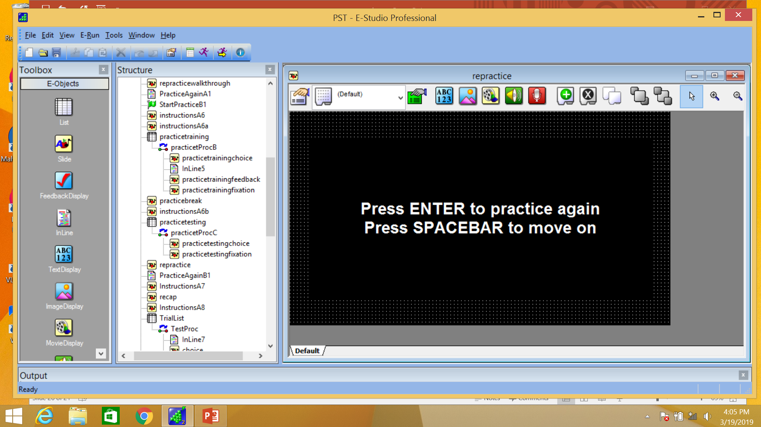

**20.** Do you feel like you need to practice this again, or would you like to move forward? [press enter to re-practice and press space to move on. If you noticed that the participant clearly did not understand the task or did not perform the task well, then repeat the practice rounds despite the participants answer. This time walk through in words how you are approaching the task].

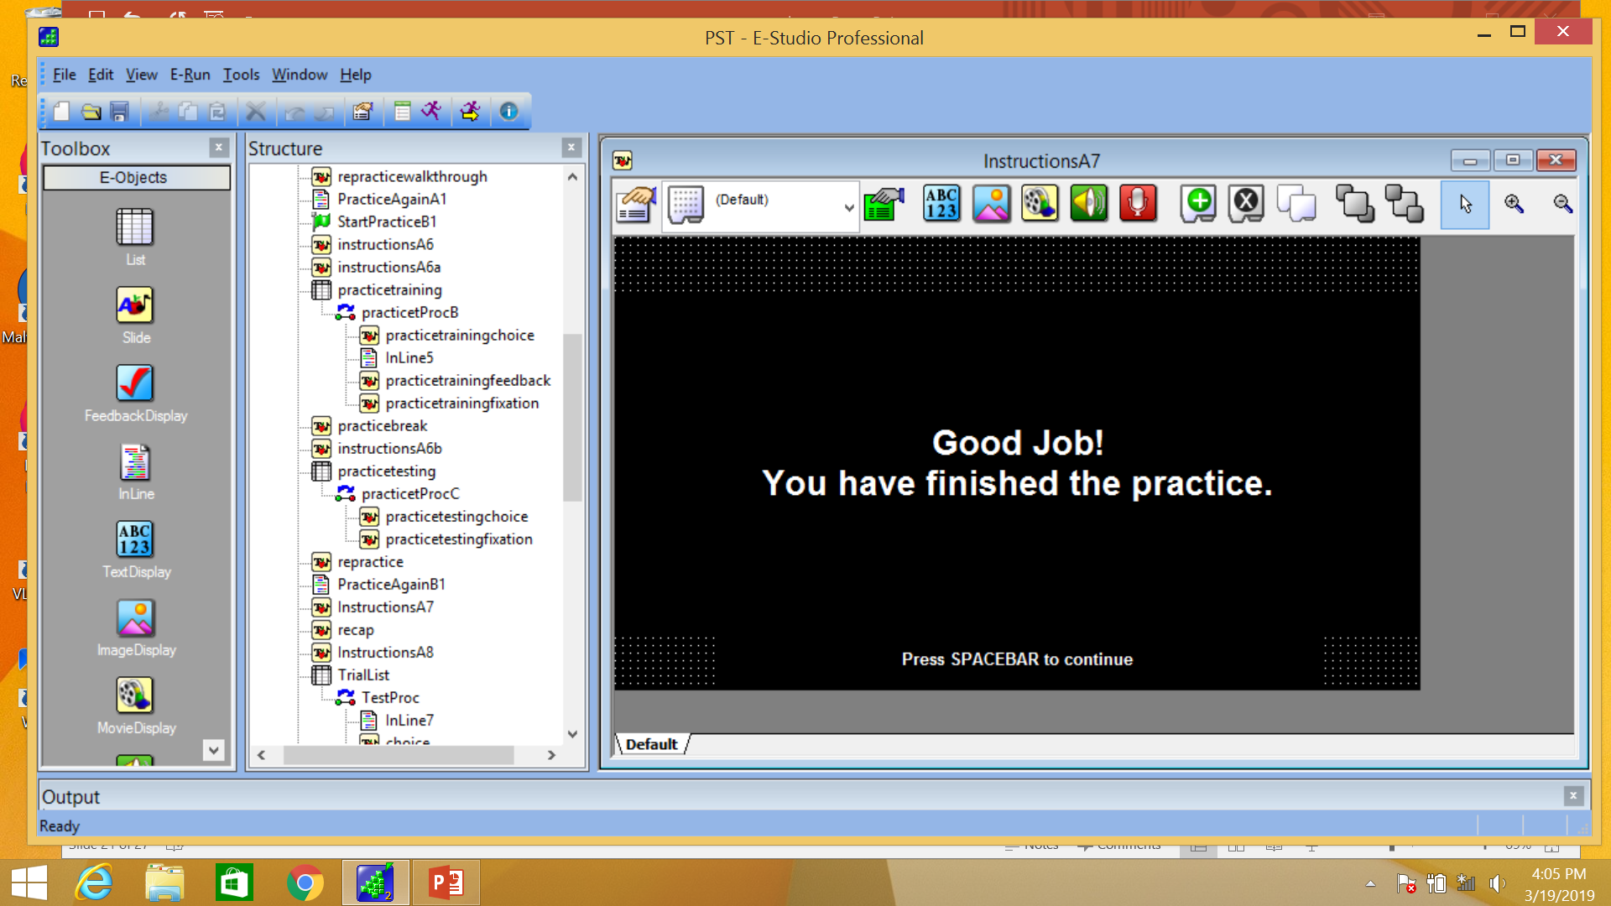

**21.** Great job! You have finished practicing the Shape Choice Task. [press space].

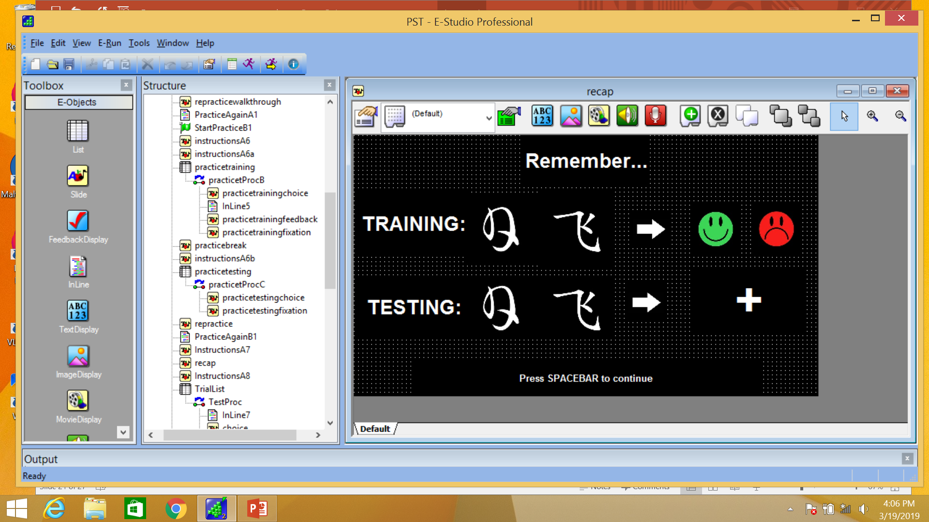

**22.** Here is a quick summary of the task: In the **training round** you will see shape pairs and you will pick the one that you think is the “correct” shape. During training, you will get feedback on your pick. In the **testing round**, you will see new shape pairs and should pick the shape you think is “correct” based on what you learned during the training. But, during this round you will NOT get feedback. [press space].

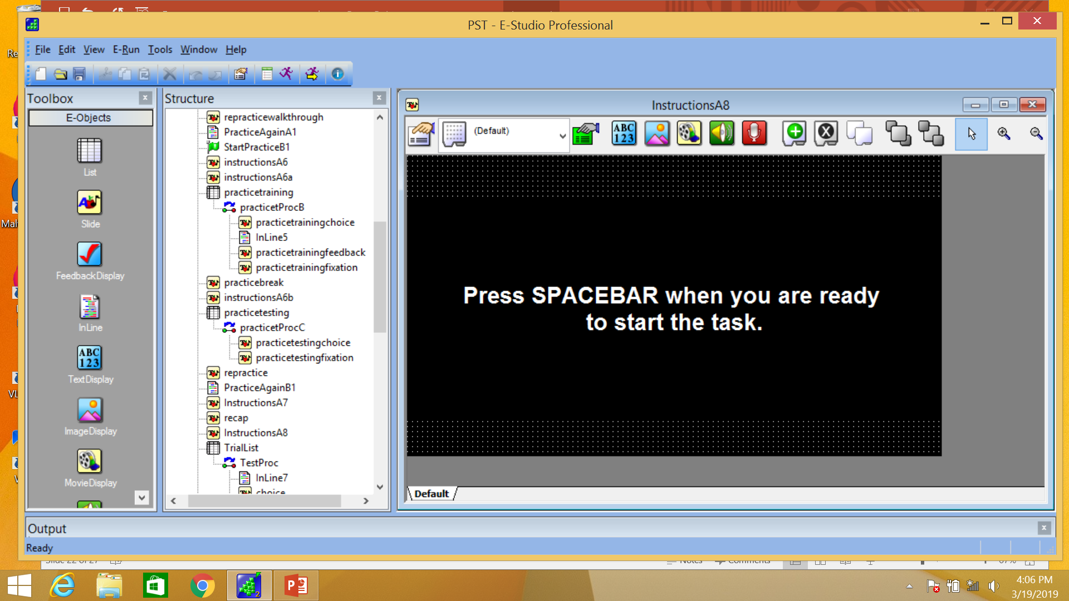

**23.** [move the computer in front of the participant] Ok, now it is time for the real task. Do you have any last minute questions? Great! Press the **spacebar** when you are ready to start.

**Training Round:**

**~150 trials (until criterion)**

**(1: shapes, 2: feedback, 3: fixation cross).**

**24.** Exact number of trials will vary depending on performance). [Answer questions, make sure room is quiet. Watch the participant closely for task compliance and understanding].

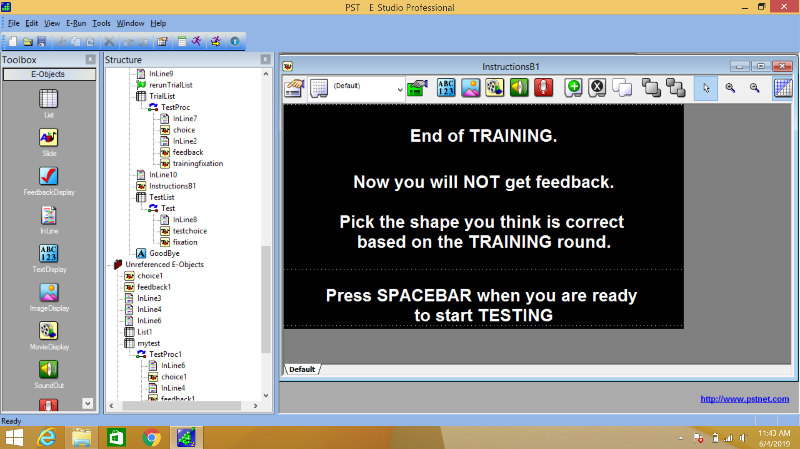

**25.** [Make sure participant knows to press **spacebar** when they are ready for testing round].

**Testing Round:**

**150 trials**

**(1: shapes, 2: fixation cross).**

**26.** Participant completes 150 testing round trials.

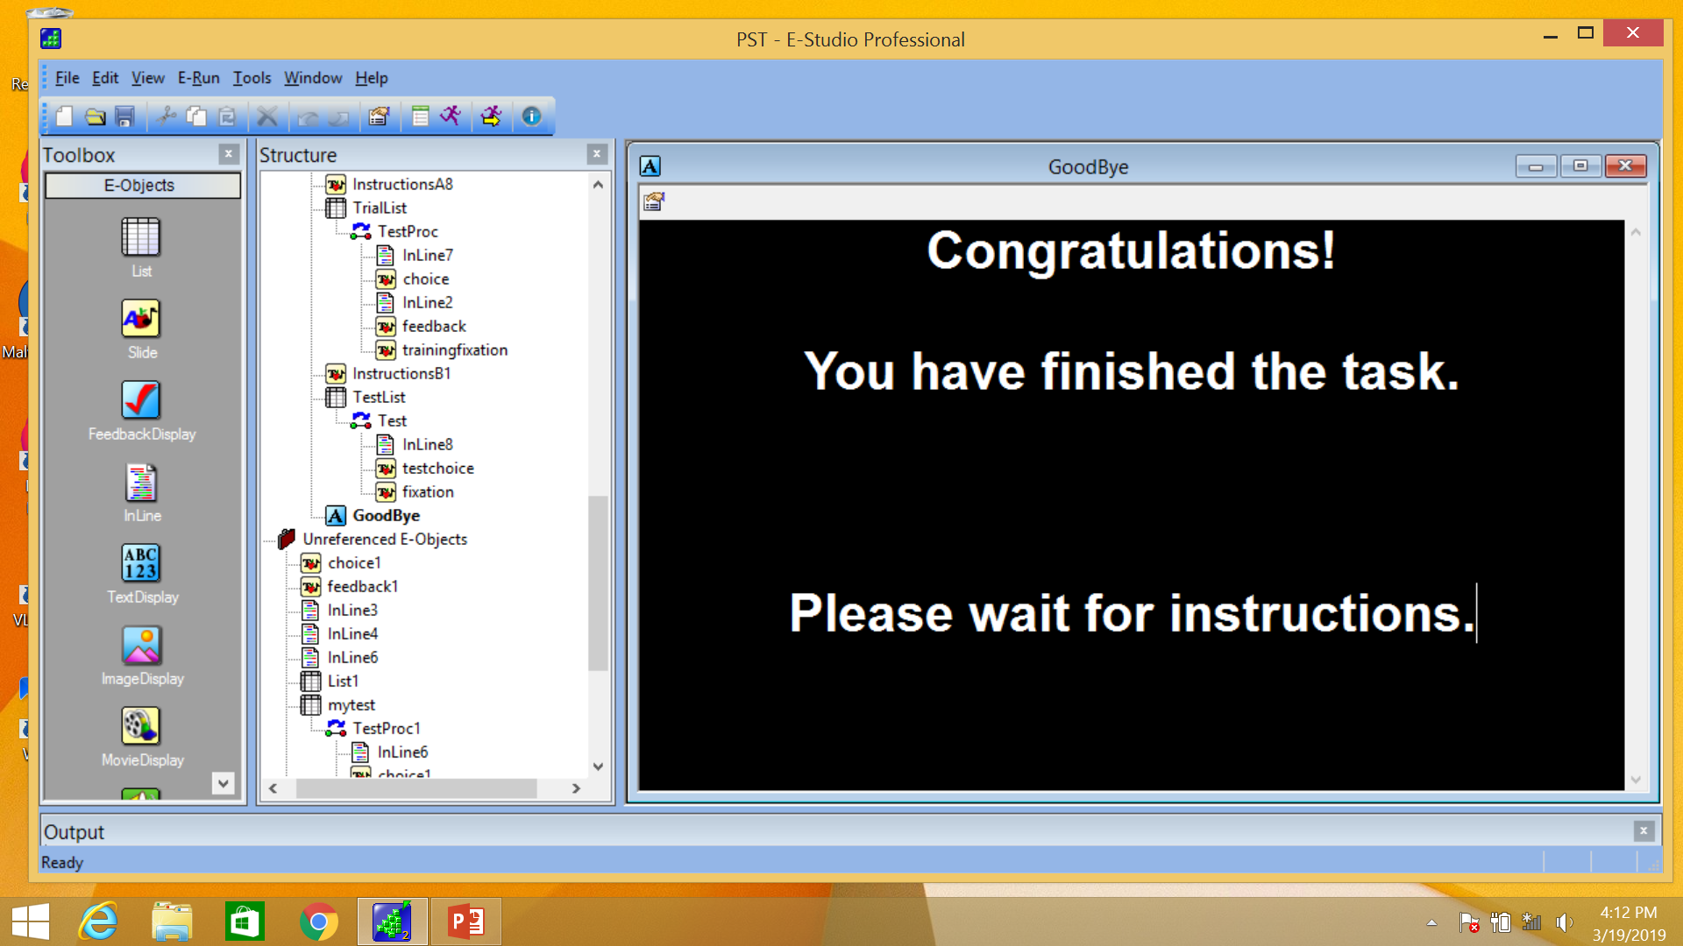

**27.** Great job! You finished the task. [experimenter presses **spacebar** to exit eprime].

**28.** Last steps

* After exiting eprime, confirm that three eprime output files with the participant’s ID number in the file name were created.
* Copy these three files to USB and then move files to ACE_DATA folder on computer.
* Shutdown computer and put computer back in case with charger and mouse.